**CHAPTER 4.0**

**SYSTEM ANALYSIS**

**4.1** **STUDY OF CURRENT SYSTEM**

The current system has been studied before the development began. Firstly, the current functionalities were observed and thoughts were given to their respective extensions. In current system there is some project available which predict the outcome for the particular tournament only.

**4.2** **PROBLEM AND WEAKNESSES OF CURRENT SYSTEM**

The current system is good for some specific tournament only also the prediction accuracy is also low for some time so chance of the prediction goes right is very law. The current system also uses only past result for predicting the winner for particular match. So, there is chance that teams may be change so the outcome will be different.

**4.3** **REQUIREMENTS OF NEW SYSTEM**

Nowadays, Cricket is the most popular sport in India. There is remarkable interest in simulating cricket and more importantly in predicting the outcome of cricket match, we have to use high accuracy algorithm for predict the outcome of the match because it is vary useful for the team management and also in the filed of fantasy sport, there is so many fantasy cricket league is for this we have to do data mining manually, so using this project the task is done by machine automatically and we get the result in few minutes without any efforts.

**4.3.1 Functional Requirements**

Requirement 1: Input Form.

I/P: User enter details like home team, away team, toss winner, and toss decision.

O/P: predicted winner between this two team.

Requirement 2: Change of dataset

I/P: After every match dataset need to update with new value.

O/P: Updated data for prediction.

**4.3.2 Non-Functional Requirements**

**Performance Requirements**: To generate the result with optimized efficiency and process it faster, a fast processor will be required so as to train the machine learning model quickly.

**Safety Requirements:** The software is an attempt to predict the result with maximum accuracy possible. Since the result is based on the current player performances, how the teams will play and probabilities from the test and train data, so 100% accuracy is impossible to achieve. Since the possibility of winning a game turns with every moment, which is what this software aims to predict accurately, the results can sometimes be not as the true outcome. The software developing company hold no responsibility if any harm or loss occurs due to the use of software results.

**Security Requirements**: The System Administrator will be responsible for keeping the database secured for access by only certain individuals. Any malicious link, or advertisements will not be shown and if it does, users are requested to click them at their own risk as they are a part of user’s client app.

**4.4 USE CASE DIAGRAM**

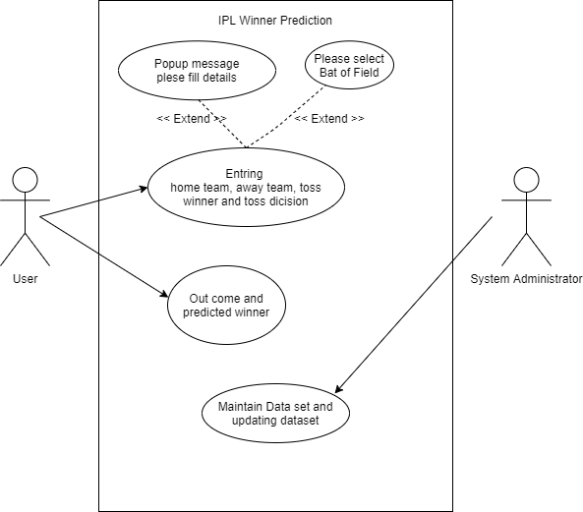

Fig 4.1 Use Case Diagram

**4.5 CLASS DIAGRAM**

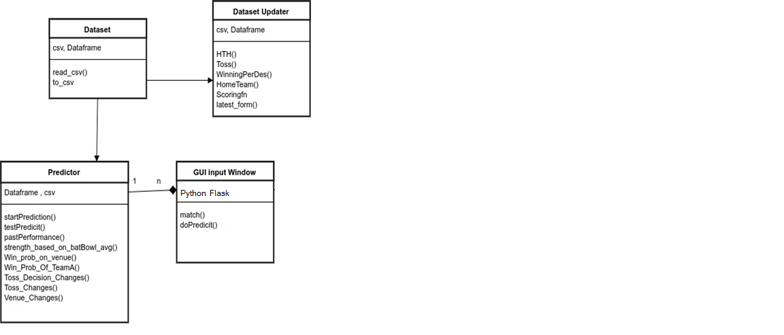

Fig 4.2 Class Diagram

**4.6 FLOWCHART OF SYSTEM**

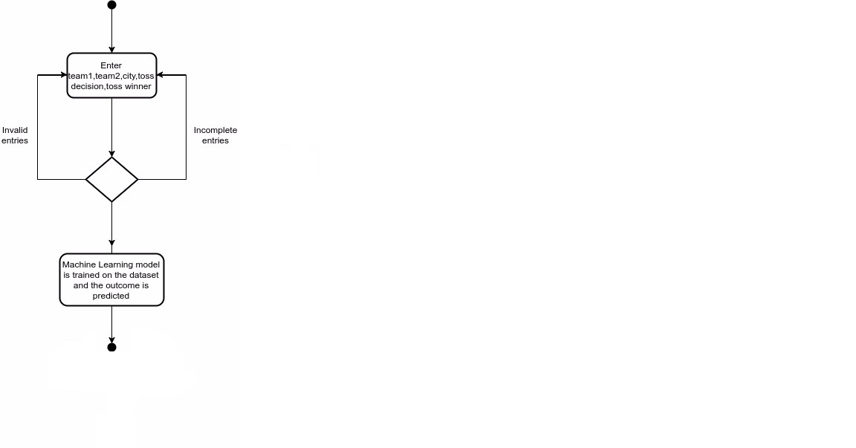

Fig 4.3 Flowchart

**4.7 SEQUENCE DIAGRAM**

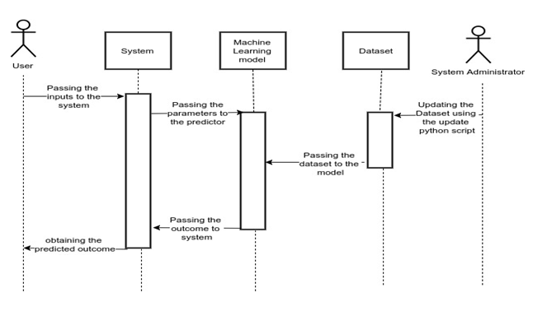

Fig 4.4 Sequence Diagram